Paul Collado
CSC-208-60
Nov 03, 2010

ColladoCh06Page277

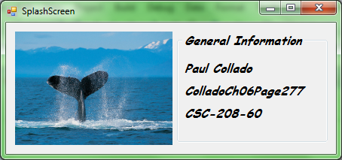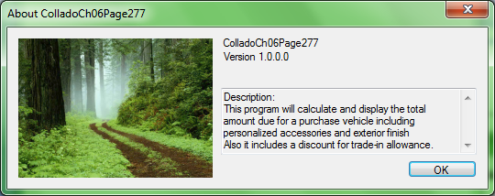
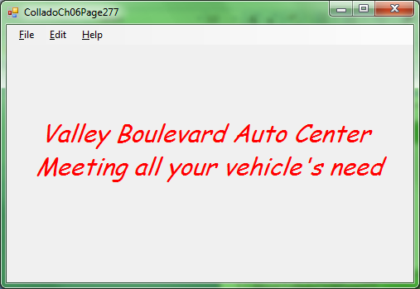
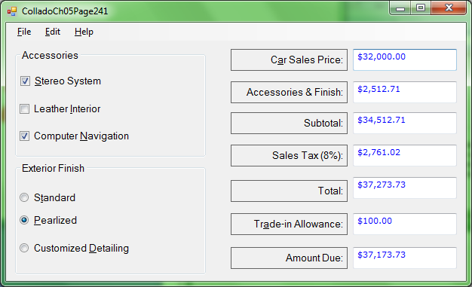
Public Class FrmColladoCh06Page277

Private Sub AboutToolStripMenuItem_Click(ByVal sender As System.Object, ByVal e As System.EventArgs) Handles AboutToolStripMenuItem.Click
AboutBox1.ShowDialog()
End Sub

Private Sub ExitToolStripMenuItem_Click(ByVal sender As System.Object, ByVal e As System.EventArgs) Handles ExitToolStripMenuItem.Click
Me.Close()
End Sub

Private Sub InputSaleToolStripMenuItem_Click(ByVal sender As System.Object, ByVal e As System.EventArgs) Handles InputSaleToolStripMenuItem.Click
FrmColladoCh05Page241.Show()
End Sub

Private Sub ColorToolStripMenuItem_Click(ByVal sender As System.Object, ByVal e As System.EventArgs) Handles ColorToolStripMenuItem.Click
Me.ColorDialog1.ShowDialog()
Me.Label1.ForeColor = Me.ColorDialog1.Color
End Sub

Private Sub FontToolStripMenuItem_Click(ByVal sender As System.Object, ByVal e As System.EventArgs) Handles FontToolStripMenuItem.Click
Me.FontDialog1.ShowDialog()
Me.Label1.Font = Me.FontDialog1.Font
End Sub
End Class

